First… then…
To anticipate a change: what happens now and what comes right after.
First | → | Then
🖨 How to print and use it
1. Print this sheet (page 1) and put it where it can be seen: the table, the fridge, the desk.
2. Print page 2 in colour and cut the cards along the dotted lines.
3. If you can, laminate them and stick a piece of velcro on the back.
4. Before a change, put one card on “First” and another on “Then”.
5. When the first one is done, take that card off: the progress is visible.
inklui.com
Based on “What do I do if…?” (ASD: anticipation) and “How do I talk to them” (rule “Anticipate changes”) · inklui.com/que-hago-si
Pictograms: ARASAAC (author Sergio Palao, Government of Aragón, CC BY-NC-SA). CC BY-NC-SA 4.0 — You may print, copy and share it non-commercially, crediting inklui. Guidance material; it does not replace assessment by a professional.


✂ To cut out · cards
  Play |   Read | 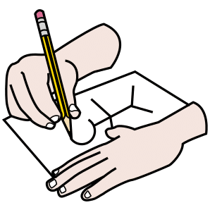  Draw |   Listen
  Work |   Wait |   Home |   School
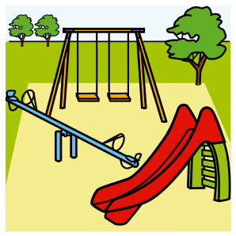  Park |   Doctor | 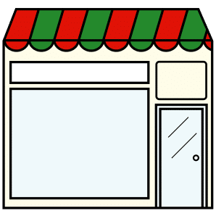  Shop

