My cards to ask for things
A keyring of basic requests. To point at when the words do not come.
  I want |   I don't want | 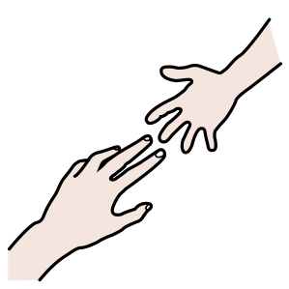  Help |   Toilet
  Water |   Eat |   Pain |   Break
🖨 How to print and use it
1. Print in colour, A4, portrait.
2. Cut the cards along the dotted lines.
3. Laminate them: small hands will not be gentle.
4. Punch a hole in one corner and put them on a ring.
5. Keep it with the person who uses it: backpack, belt, chair.

  Happy |   Sad |   Angry |   Scared
  Tired |   OK
inklui.com
Based on “Communication cards” · inklui.com/tarjetas-comunicacion
Pictograms: ARASAAC (author Sergio Palao, Government of Aragón, CC BY-NC-SA). CC BY-NC-SA 4.0 — You may print, copy and share it non-commercially, crediting inklui. Guidance material; it does not replace assessment by a professional.


